**USING 5FIRECHAIN PLATFORM FOR DEPLOYING SMART CONTRACT**

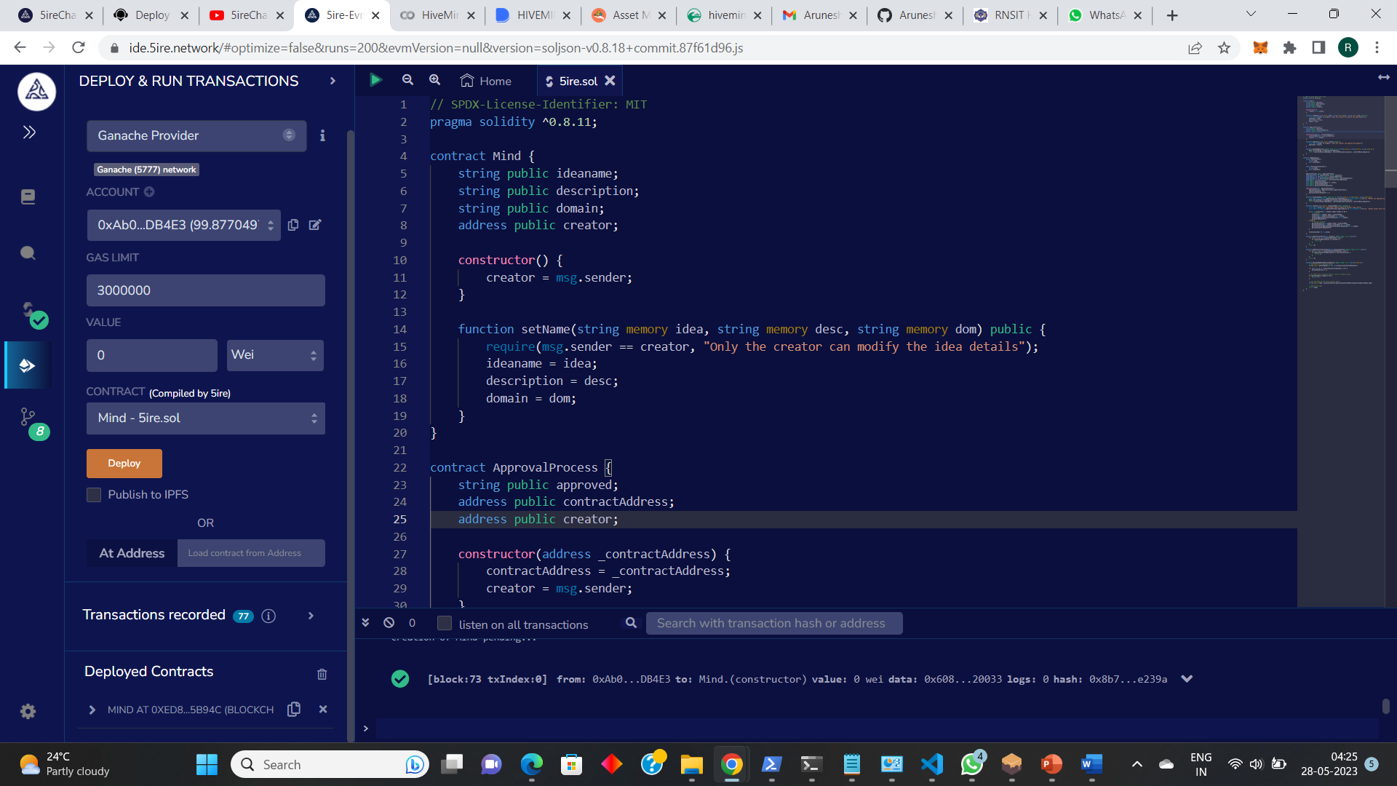

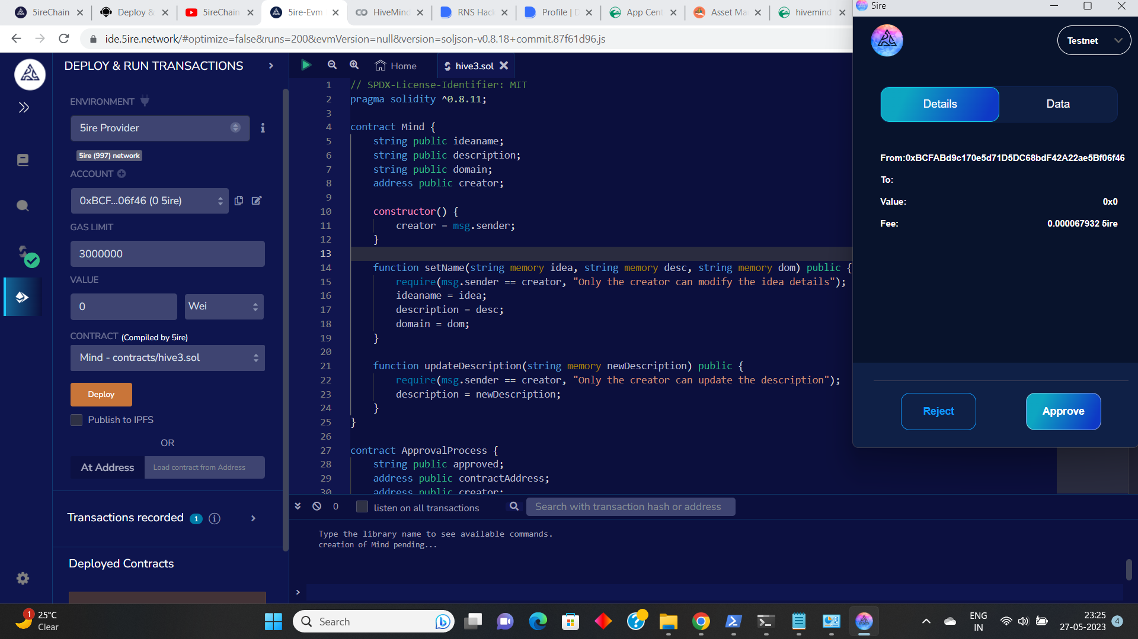

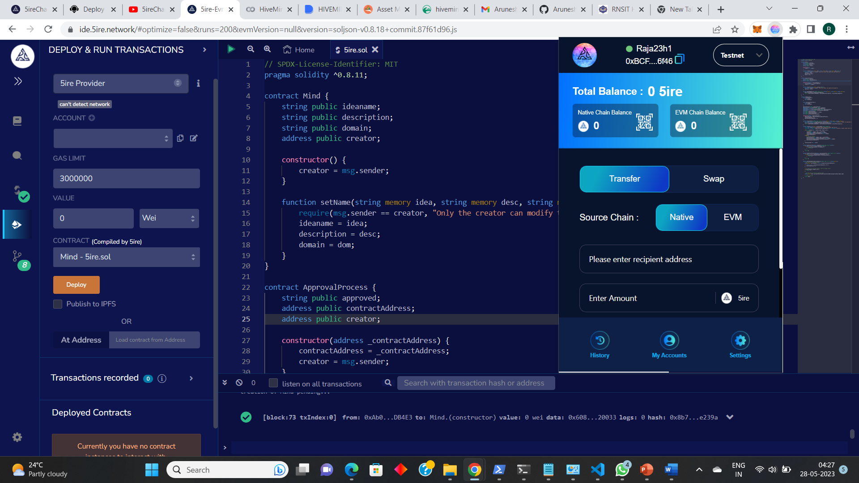

We deployed our smart contract in 5irechain IDE and connected with 5irechain wallet. With 5irechain's dynamic potential, we are delighted to be one of the platform's users. We utilised the Goerli Testnet to test our block, and we set up IPF5 to ensure that the contents could be shared and stored.